**Applecross Senior High School**

**Year 11 Human Biology 2A**

**Test 2 2017**

**Section A Multiple Choice (20 marks)**

1. During the cardiac cycle the following events take place:

* atrial systole
* diastole
* ventricular systole

In which order do the events occur?

1. atrial systole, diastole, ventricular systole
2. diastole, ventricular systole, diastole
3. ventricular systole, atrial systole, diastole
4. atrial systole, ventricular systole, diastole

2. Most oxygen and carbon dioxide in the blood is carried in the form of:

1. carbonic acid & haemoglobin ion
2. bicarbonate ion & hydrogen ion
3. oxyhaemoglobin & bicarbonate ion
4. haemoglobin ion & water

3. The right ventricle of the heart pumps:

1. oxygenated blood to the rest of the body
2. deoxygenated blood to the right atrium
3. deoxygenated blood to the lungs
4. oxygenated blood to the right atrium

4. Which of the following play an important role in the clotting of blood?

1. Leucocytes
2. Thrombocytes
3. Erythrocytes
4. lymphocytes

5. Erythrocytes, leucocytes, thrombocytes and plasma are all components of blood, below is a table illustrating one feature of each – which is **CORRECT**.

|  |  |  |  |  |
| --- | --- | --- | --- | --- |
|  | **erythrocyte** | **leucocyte** | **thrombocyte** | **plasma** |
| (a) | biconcave | granular/agranular | no nuclei | liquid |
| (b) | biconcave | no nuclei | combats inflammation | contains solutes |
| (c) | contains haemoglobin | combats inflammation | large comparatively | mostly water |
| (d) | no nuclei | large comparatively | > numerous than erythrocytes | a formed element |

Table 1: Features of Blood

6. The semilunar valves prevent the backflow of blood from the

1. ventricles into the atria.
2. arteries into the ventricles.
3. atria into the veins.
4. atria into the ventricles.

7. The rings in the wall of the trachea

1. prevent it collapsing under pressure
2. make it larger
3. prevent it filling with mucus
4. enable air to be forced out of the lungs

8. When air is inhaled it flows through the air tube system to reach the air sacs.

What order does the air follow?

1. Nasal cavity, Trachea, Bronchi, Pharynx, Bronchioles, Larynx.
2. Nasal cavity, Bronchi, Larynx, Trachea, Pharynx, Bronchioles.
3. Nasal cavity, Pharynx, Larynx, Trachea, Bronchi, Bronchioles.
4. Nasal cavity, Bronchi, Bronchioles, Trachea, Pharynx, Larynx.

9. The functional units of the respiratory system where gas exchange occurs are the:

1. Alveoli
2. terminal bronchioles
3. pulmonary vessels
4. lungs

10. Mucus secreted by the epithelial cells of the trachea

1. lubricates the trachea to facilitate the movement of air into the lungs.
2. moistens the incoming air so that the alveoli do not dry out.
3. traps dust particles in inspired air.
4. warms the incoming air so that core body temperature is not reduced.

11. Contraction of the diaphragm muscle results in

1. a decrease in the volume of the thoracic cavity
2. an increase in the volume of thoracic cavity
3. expiration
4. peristalsis

12. The vocal cords are two folds of mucus membrane protruding from the lining of the:

1. larynx
2. bronchus
3. Pharynx
4. trachea

13. Hypertension is

1. tension in the heart muscle
2. high blood pressure
3. another name for stress
4. the cause of stomach ulcers

Below is an **incomplete** table regarding human blood grouping. If the table was being completed by a student, what correct information would be required in the table as indicated by the letters V, W, X, and Y in questions Q 14, Q15 and Q16?

|  |  |  |  |
| --- | --- | --- | --- |
| Blood group | Antigens on surface | Antibodies in plasma | Blood Transfusions |
| AB |  | V | W |
| A type blood | X |  |  |
| B type blood |  |  |  |
| O negative blood |  | Y |  |
| O positive blood |  |  |  |

Table 2. Blood Grouping

14. The letter V would represent

a) Antibody A only

b) Antibody B only

c) Both antibodies A and B

d) That no antibodies are present

15. The letter W would represent

a) It is the universal donor; it can give blood to all other blood types

b) It is the universal recipient; it can receive blood from all other blood types

c) It is neither the universal donor nor recipient because of its antibodies

d) It is only compatible with its own blood group

16. The letter X would represent

a) A antigens

b) B antigens

c) A antibodies

d) X antigens

17. The letter Y would represent

a) O antibodies

b) O- antibodies

c) Antibodies A, B and D

d) Antibodies A and B but no D antibodies

|  |
| --- |
|  |
| 18. | | Lymph most closely resembles which of the following? |
|  |
| 1. Plasma 2. Urine 3. Tissue fluid 4. Blood |

Use the diagram below to answer **Questions 19 and 20**

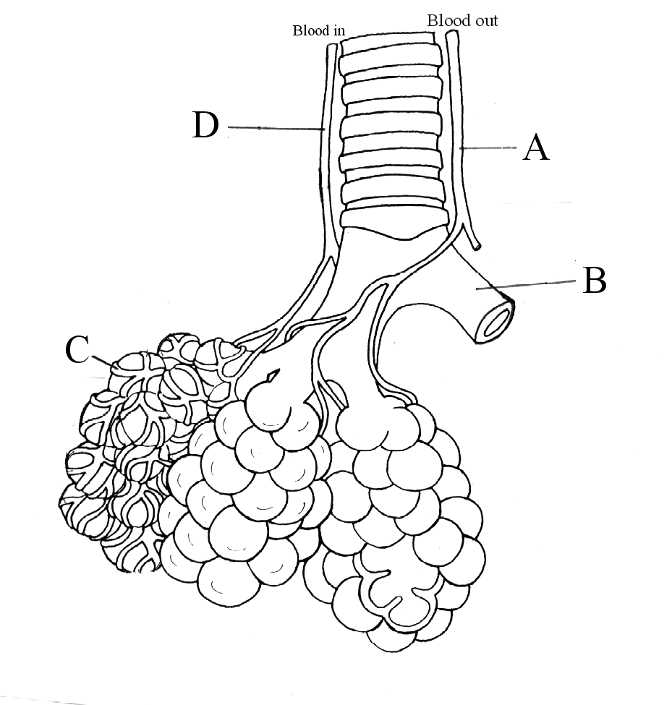

19. Blood vessel D would be a branch of the

a) pulmonary artery.

b) pulmonary vein.

c) coronary artery.

d) coronary vein.

20. Within the capillary network gaseous exchange takes place. During expiration, the blood in vessel C would have a:

a) high concentration of carbaminohaemoglobin and low oxyhaemoglobin concentration.

b) low concentration of carbaminohaemoglobin and a high bicarbonate ion concentration.

c) low concentration of carbaminohaemoglobin and a high concentration of oxyhaemoglobin.

d) low concentration of oxyhaemoglobin and a low concentration of carbaminohaemoglobin.

**PART B SHORT ANSWER SECTION 30 MARKS**

21. Complete the Table below for each type of blood vessel stated, giving (a) one function it serves, and (b) one structural feature which helps it carry out the function.

|  |  |  |
| --- | --- | --- |
| **Blood Vessel** | **Function** | **Structural Feature** |
| 1. Artery | (a) | (b) |
| 2. Capillary | (a) | (b) |
| 3. Vein | (a) | (b) |

(6 marks)

22. The process of respiration involves several processes and structures. Give the correct **biological term** described by the following.

1. A flap of tissue which, when swallowing, closes off the trachea so that food and liquid cannot enter the lungs.

_____________________

1. The membrane which covers the lungs and lines the inside of the chest.

_____________________

1. Muscles between the ribs which move the rib cage upwards and outwards to increase the volume of the lungs.

_____________________

1. Gas which diffuses from the blood into the lungs.

_____________________

1. Sudden paralysis of the body due to interruption of blood supply to brain _______________________
2. Constriction/inflammation of bronchioles is a symptom of which respiratory disease?

_________________________ (3 marks)

Use the diagram below to answer parts a) to e) of question 23.

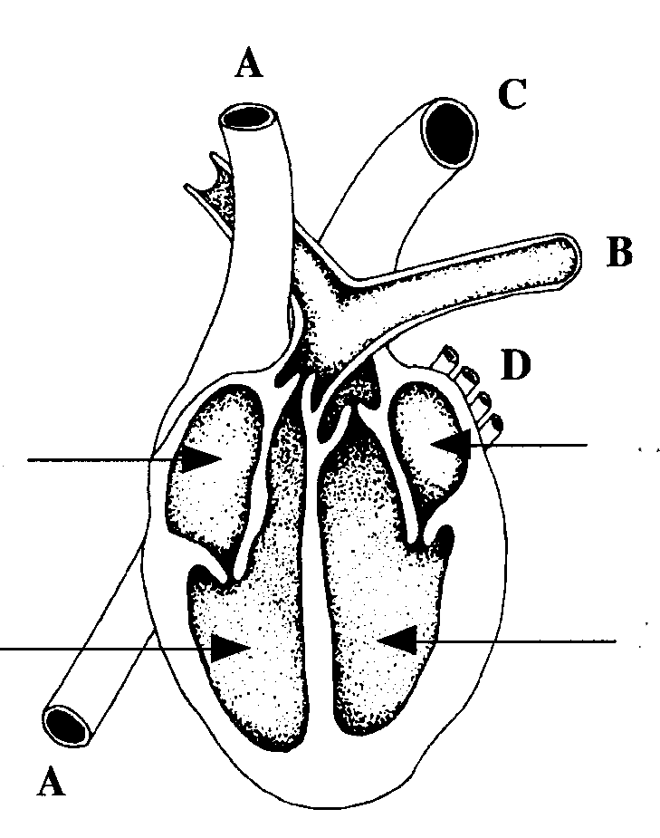

**H**

**G**

**F**

**E**

23. (a) Using the **letters** indicated on the diagram state which **vessels** and which **chambers** contain **oxygenated** blood. (4)

_____________________________________________________________

(2 marks)

(b) Name the structures labelled

C ________________________________________________

E ________________________________________________ (2 marks)

1. Describe the pathway taken by the blood in the pulmonary circulation, starting from when the blood returns to the heart from the systemic circulation.

________________________________________________________________

________________________________________________________________

________________________________________________________________

________________________________________________________________

________________________________________________________________

(2 marks)

(d) Explain why the walls of the chambers of the heart are of different thickness.

________________________________________________________________

________________________________________________________________

________________________________________________________________

________________________________________________________________

________________________________________________________________ (2 marks)

(e) If a person required first aid for a badly cut arm, how would you know whether an artery was bleeding or a vein was bleeding?

________________________________________________________________

________________________________________________________________

________________________________________________________________

________________________________________________________________

________________________________________________________________

________________________________________________________________

(2 marks)

**LEFT INTENTIONALLY BLANK**

24. The diagram below refers to parts (a) to (d) of Question 24.

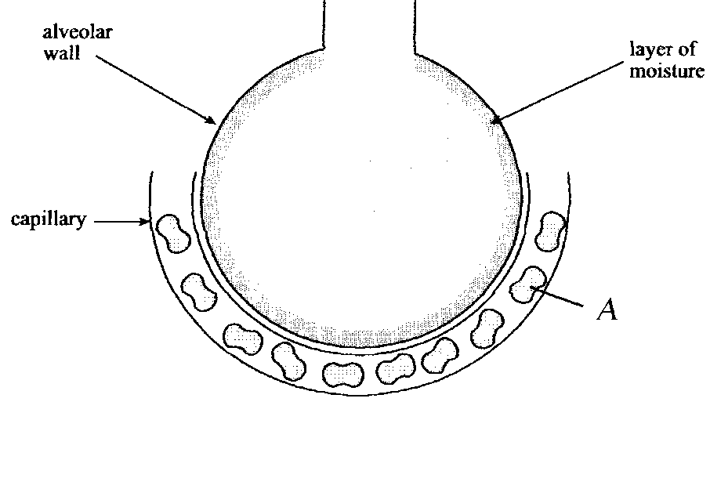

1. State **ONE** function of the layer of moisture that lines the alveolar wall.

____________________________________________________________________ (1 mark)

1. Name **ONE** other structural feature of the alveolar wall tissue and describe the how it facilitates efficient gas exchange.

_____________________________________________________________________

______________________________________________________________________

______________________________________________________________________

(2 marks)

(c) What is structure A, and what roles does it perform in the gas exchange in the lungs?

__________________________________________________________________________________________________________________________________________________________________________________________________________________

______________________________________________________________________

______________________________________________________________________

(3 marks)

25. Expired air and inspired air differ in composition. The following table gives an approximate comparison.

|  |  |  |
| --- | --- | --- |
|  | **INSPIRED AIR**  **(Total volume)** | **EXPIRED AIR**  **(Total volume)** |
| Oxygen | 21% | 17% |
| Carbon Dioxide | 0.04% | 4% |
| Nitrogen and inert gases | 78% | 78% |
| Water vapour | Varies | Saturated |
| Temperature | Atmospheric | Body (37o C) |

Explain the differences or the lack of difference between the inspired and expired values shown in the table.

______________________________________________________________________________________________________________________________________

_________________________________________________________________________________________________________________________________________________________________________________________________________

__________________________________________________________________________________________________________________________________________________________________________________________________________________________________________________________________________________________________________________________________________________________________________________________________________________

__________________________________________________________________________________________________________________________________________________________________________________________________________________________________________________________________________________________________________________________________________________________________________________________________________________ (5 marks)

**NOTES**

______________________________________________________________________________________________________________________________________

_________________________________________________________________________________________________________________________________________________________________________________________________________

__________________________________________________________________________________________________________________________________________________________________________________________________________________________________________________________________________________________________________________________________________________________________________________________________________________

_________________________________________________________________________________________________________________________________________________________________________________________________________

__________________________________________________________________________________________________________________________________________________________________________________________________________________________________________________________________________________________________________________________________________________________________________________________________________________

____________________________________________________________________________________________________________________________________________________________________________________________________________________________________________________________________________